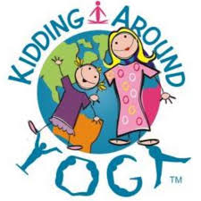 |  | KAY Yoga  For Children Ages 3-10
Yoga Teacher  Ruthie VanGorder is a certified KAY yoga instructor as well as a pediatric Occupational Therapist. She combines her knowledge of child development, sensory regulation and motor planning with her knowledge of yoga to provide a therapeutically based yoga session for your child.  Contact  PHONE:  585-766-9000  WEBSITE:  Cobblestoneartscenter.com  EMAIL:  ruthievot@gmail.com  where:  Cobblestone Arts Center  1622 State Route 332  Farmington, NY 14425  Cost:  $10/per class  When:  Wednesdays @ 4:00  Session 1: 9/18-11/20  Session 2: 1/8-3/18  Session 3: 4/21-6/9 |  | Join us for a jam-packed time of music, movement, breath and meditation. Your child will learn how to integrate moments of meditation and movement into their lives and how to begin to cultivate healthy lifestyle habits!  What is KAY yoga?  KAY stands for Kidding Around Yoga and was founded by Haris Lender. KAY Yoga is registered through the Yoga Alliance and is inspiring young children to embrace yoga in active and engaging ways.  What will class be like?  Your child’s Kidding Around Yoga (KAY) class will provide opportunities to learn, move and breath in an engaging, fun and active Yoga style. Your child will learn the basic principles of Yoga which will teach them tools for self-regulation, stress management and improved motor planning using movement, music and meditation. The class will emphasize how Yoga can be incorporated into daily life to support self-regulation and mindfulness!

